

**Semester 2 Seminar Schedule**

|  |  |  |
| --- | --- | --- |
| Date | Speaker | Affiliation |
| 29 July | **Alicia Oshlack** | Murdoch Children’s Research Institute |
| 5 August | **Joseph Powell** | IMB,  University of Queensland |
| 12 August | **Sue Wilson** | Australian National University & UNSW |
| 19 August | **Nick Hamilton** | IMB,  University of Queensland |
| 26 August | **Agus Salim** | La Trobe University |
| 2 September | **Mirana Ramialison** | ARMI,  Monash University |
| 9 September | **John Moreau** | Earth Sciences,  University of Melbourne |
| 16 September | **David Warton** | University of NSW |
| 23 September | **TBC** |  |
| 7 October | **Jane Elith** | BioSciences,  University of Melbourne |
| 14 October | **Greg Gibson** | Center for Integrative Genomics, Georgia Tech |
| 21 October | **Jean Yang** | University of Sydney |
| 28 October | **No seminar** |  |
| 4 November | **Laura Boykin** | University of Western Australia |
| 11 November | **Sean Grimmond** | Centre for Cancer Research, University of Melbourne |
| 18 November | **Lachlan Coin** | IMB,  University of Queensland |
| 25 November | **Justin Rubio** | Florey Institute of Neuroscience and Mental Health |

All seminars start at 11am on a Friday, unless otherwise specified

ESJ King Theatre, 3rd Floor, Medical Building

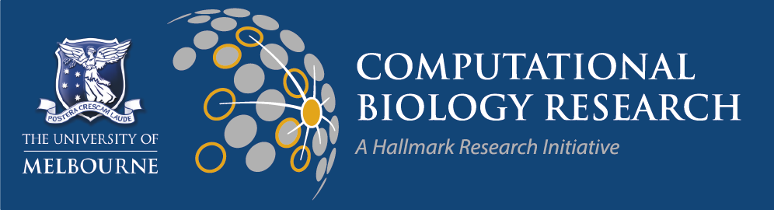The University of Melbourne