

**Semester 1 Seminar Schedule**

|  |  |  |
| --- | --- | --- |
| Date | Speaker | Affiliation |
| 18 March | **Jukka Corander** | University of Helsinki, Finland |
| 15 April | **Liam Fearnley** | Centre for Systems Genomics  University of Melbourne |
| 22 April | **Christine Wells** | Anatomy & Neuroscience  University of Melbourne |
| 29 April | **Ashley Farlow** | Centre for Systems Genomics  University of Melbourne |
| 6 May | **Sebastian Duchene** | Charles Perkins Centre  University of Sydney |
| 13 May  **11:15am start | **Phil Batterham** | BioSciences & Bio21 Institute  University of Melbourne |
| 20 May | **Lan Nguyen** | School of Biomedical Science  Monash University |
| 27 May | **Sarah Dunstan** | Doherty Institute  University of Melbourne |
| 3 June | **Quin Wills** | Oxford University, UK |
| 10 June | **Melanie Bahlo** | Walter & Eliza Hall Institute |
| 17 June | **Jonathan Keith** | School of Mathematical Sciences  Monash University |
| Monday  27 June | **Daniel Falush** | Swansea University, UK |
| 1 July | **Hannes Svardal** | Sanger Institute, UK |
| 8 July | **Daniel Wilson** | Oxford University, UK |
| 15 July | **Lesley Gray** | Centre for Systems Genomics  University of Melbourne |
| 22 July | **Sarah Medland** | QIMR Berghofer Medical Research Institute |

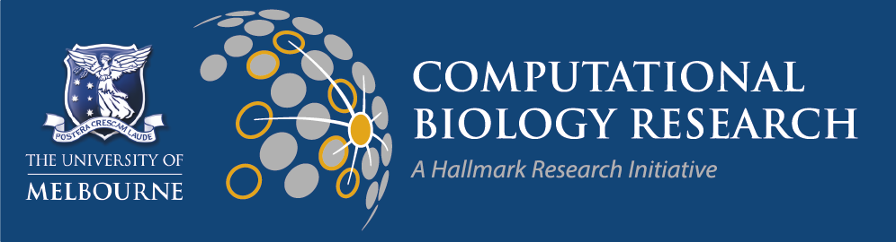All seminars start at 11am, unless otherwise specified

ESJ King Theatre, 3rd Floor, Medical Building

The University of Melbourne